City Management

The City Management feature allows us to insert the deatils of a new city that houses a project associated with either PropTiger or Makaan and is a fresh entry with regards to the project involved.
Parameters like the current status of the city (active or inactive in case of no active porojects), the geographical details (latitude, longitude etc.) may be inserted.

A further division of a city may be made as suburb and locality.

In which there are following section
- Search city by first alphabet.
- Edit city.
- Add city.

Search city: Search city by first alphabet. After that we can easily edit there information.

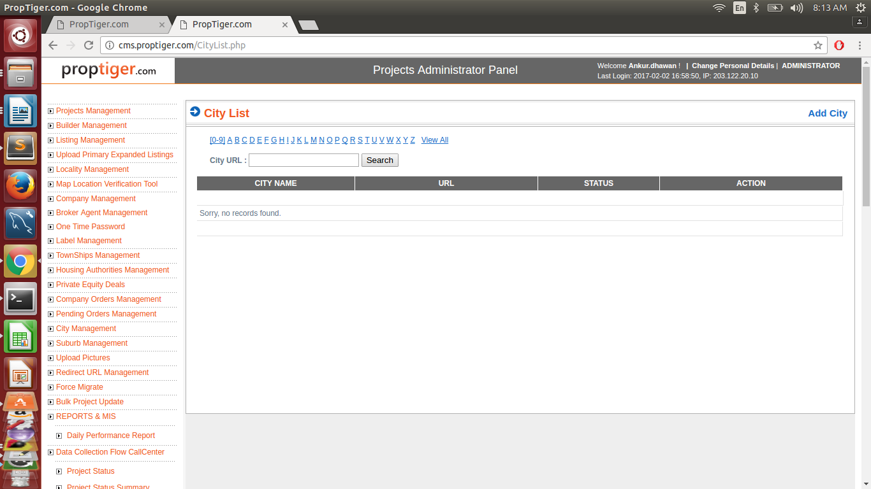

Add city:

This feature allows to add new cities to the database and functions on the basis of a few parameters listed below.

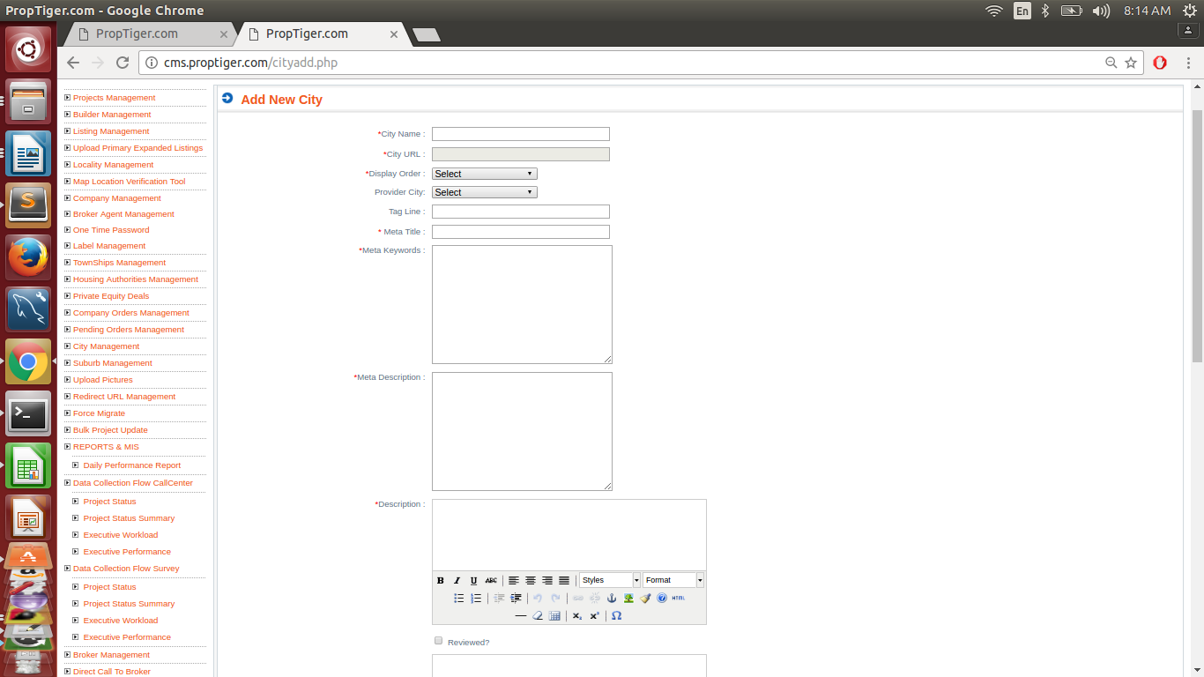

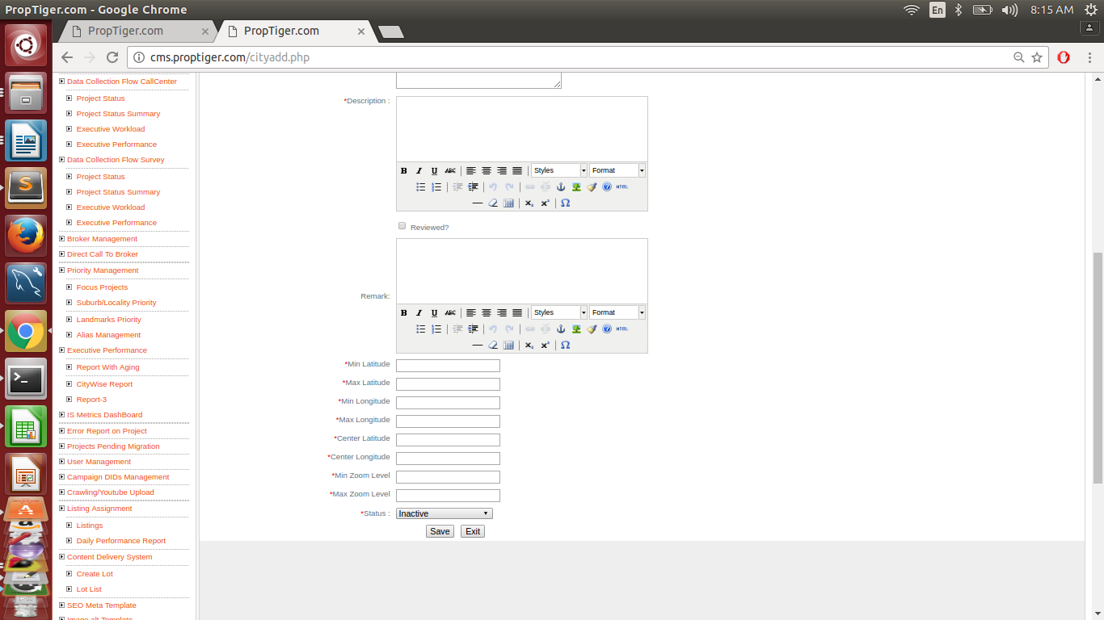
NOTE :
A city may be made Inactive only and only when all the suburbs are in Inactive status.
Any new city created may correspond to either Active or Inactive status.

All entries are fill in the following table:
- City.
- Seo_data.

1.*City_name city
2.*url(automatically formed) city
3.*Display_order city
4.Provider city city
5.Tag line
6.*Meta title seo_data
7.*Meta Keywords seo_data
8.*Meta description seo_data
9.Other Description( in case of editing)
10.*Description city
11.Reviewed
12.Remark
13.city cleaned ( in case of editing)
14.*Min latitude city
15.*Max latitude city
16.*Min longitude city
17.*Max longitude city
18.*Center Latitude. city
19.*Center longitude. city
20.*Min zoom level. city
21.*Max zoom level city
22.*status city

Query:

Query for checking mandatory filed is null.

Select ci.label,ci.url,ci.display_order.sd.meta_title,sd.meta_keywords,sd.meta_description
ci.description,ci.center_latitude,ci.center_longitude,ci.min_zoom_level,ci.max_zoom_level,
ci.status from city ci join seo_data sd on ci.city_id=sd.table_id

